|  |  |  |
| --- | --- | --- |
| SERENE AMS | November 20  2019 | |
|  | | SERENE AMS |



**Student’s Name:**  Owais Mumtaz, Muhammad Afzaal

**Student ID:** 61316, 61243

**FYP1 / FYP 2:**  FYP-1

**Project Title:** SERENE AMS

**Project Category**: Software Application Development

**Supervisor:** Miss Mahrukh

**CONTENTS:**

**Business Case……………………………………………………………………………..5**

CURRENT IMPLEMENTATION………………………………………......................................................6

REASONS FOR CHANGE……………………………………………………………………………….......6

BENEFITS……………………………………………………………………………………………………...7

KPI’S…………………………………………………………………………………………………………….8

RISK……………………………………………………………………………………………………………..8

COST…………………………………………………………………………………………………………….8

CONCLUSION………………………………………………………………………………………………….9

**PROJECT CHARTER……………………………………………………………………..10**

PROBLEM STATEMENT……………………………………………………………………………………..11

PROBLEM DESCRIPTION……………………………………………………………………………………11

CRITICAL SUCCESS FACTOR………………………………………………………………………………12

ASSUMPTIONS…………………………………………………………………………………………………12

CONSTRAINTS………………………………………………………………………………………………….12

**PROJECT PLAN…………………………………………………………………………….13**

**WORK BREAKDOWN STRUCTURE……………………………………………………..15**

PHASES…………………………………………………………………………………………………………...15

TASKS……………………………………………………………………………………………………………...15

**CONFIGURATION DOCUMENT…………………………………………………………….17**

**FINANCIAL IMPACT………………………………………………………………………….27**

**AS-IS-PROCESSES…………………………………………………………………………..29**

**GAP ANALYSIS……………………………………………………………………………….43**

**TO-BE-PROCESSES…………………………………………………………………………45**

**UML DIAGRAMS……………………………………………………………………………...52**

# **BLUEPRINT AGREEMENT**

Signing this document records your agreement to the contents of the Business Blueprint, and confirms that the remainder of the project can proceed.

**Reviewed and Approved by:**

|  |  |  |  |  |
| --- | --- | --- | --- | --- |
| **Name** | **Company** | **Position** | **Date** | **Signature** |
|  |  |  |  |  |
|  |  |  |  |  |
|  |  |  |  |  |
|  |  |  |  |  |
|  |  |  |  |  |

**Prepared / Verified by:**

|  |  |  |  |
| --- | --- | --- | --- |
| **Name** | **Position** | **Date** | **Signature** |
| xxxxx | Project Manager |  |  |
| Module Consultant | HR MANAGER SERENE |  |  |

# **LEGENDS:**

|  |  |  |  |
| --- | --- | --- | --- |
| ‘= | Process Activity Related to other Module |  | Decision |
|  | Performed automatically by SYSTEM. |  | Task Manually input in the System |
|  | Activity step |  | Document |
|  | System |  | Exclusive task  perform |
|  | Multiple task performs  At same time |  | Report or document generated from SAP. |

**BUSSINESS CASE**



|  |  |  |  |
| --- | --- | --- | --- |
| **SUBMITTED TO** | Miss Marrukh | **SUBMITTED BY** | M.Afzaal And Owais Mumtaz |
| **TO THE ATTENTION OF** |  | **POINT OF CONTACT** | 021-34570303 |
| **ADDRESS** | Serene Air | **ADDRESS** | Concourse Hall level-2, Opposite  Domestic Departure gate, Jinnah International Airport JIAP Karachi |
| **PHONE** | Concourse Hall level-2, Opposite Domestic Departure gate, Jinnah International Airport JIAP Karachi | **PHONE** | 021-34570303 |
| **EMAIL** | **customeraffairs@sereneair.com** | **EMAIL** | **customeraffairs@sereneair.com** |
| **DATE SUBMITTED** | 26-oct-2019 | **DELIVERY METHOD** | Software Develiarable |

|  |
| --- |
| **EXECUTIVE SUMMARY** |
| The project will help serene departments to integrate and work efficiently and manage things on one  Platform. |
| **CURRENT IMPLEMENTATION** |
| Serene is using software name oasis(oases) which is Airline specific and only used for Financial purpose. Payroll and  Other procurements billings and records are kept in this. |
| **REASON FOR CHANGE** |
| Serene don’t want to change their system but they are facing problems with regards to their departments  Integration like Material Management records and other processes of Human Resource Management are not easy  to manage and keep data so they want a management system for their Airline which bring their major department  On one platform. |
| **FINDING A NEW IMPLEMENTATION** |
| Serene is finding a management system which will be efficient enough to work properly in their organization and  Provide up to date features and lessened their time of bussiness processes. |
| **POSSIBLE VENDORS** |
| As serene do procurement of two basic things which Airline require that is Fuel and maintaince parts. They have  Separate warehouses for Inventory management and individual department for Material Management. They also  Import Maintainess items so there is a list of vendors they have to do so. |
| **BENEFITS OF AN UPDATE** |
| Airline like Serene Air (which is new in aviation industry) the Goods management of imported item and commercial  Items is mostly complex, and it can be difficult for Store Officer to check items. Also, Administration has to contact  Finance department for payroll and other expenses as well as details about employee. Items that are being  Procured their quantity will be recorded in mm module. The value of these items will be recorded in fi module. So,  This System can be helpful for Hr, Finance and inventory. The main idea behind Project is to automate business  process of an airline department of Hr, Finance and Supply chain which can help in improving administration  Management, Accounts Management and Inventory Management. |
| **KEY PERFORMANCE INDICATORS** |
| 1. Inventory Control 2. Avoid stock-outs and excess stock 3. Quality Management like approval from supervisor that   Imported items are qualified to use.   1. Inventory Reports and financial reports. 2. Administration Management through Hr. 3. Leave and time Management. |
| **IMPLEMENTATION RISKS** |
| * Computer virus. * Hacker. * Operational Risk. * Information security Risk |
| **OPTION COSTS** |
| Phase I: Initial Consultation One Time Monthly Cost  - Conduct meetings with Serene Air HR, inventory, finance staff No Cost No Cost  - Determine gaps, application needs, recommendations No Cost No Cost  Phase II: Solution Design  - Develop application based on client requirements Rs 50,000 None  - Conduct Beta testing and application revisions Rs 5000 None  - Finalize solution and provide client tech. data package Rs 25,000 None  Phase III: Implementation  - Load application on Serene Air Infrastructure Rs 15,000 None  - Establish Serene Air in Data Center Rs 10,000 None  - Handoff to Operations/Project Close Out Rs 12,000 None  Phase IV: Management and Support  - Client Technical Support None Rs 20,000  Totals Rs 117,000 Rs 20,000 |
| **IMPLEMENTATION PROGRAM** |
| We will work with the client to design the solution based on the needs of the company. This tailored approach  allows Serene Air to ensure they gets the solution they need and does not have to pay for excess services which  They will not use. We will implement the solution in a seamless manner that will be transparent to daily operations. |
| **CONCLUSION** |
| The minimum term for this contract is 9 months from the time of project closeout and beginning of management  And operations of the solution. Any additional work required by the client outside of the scope of the contract will  Be charged. Technical support will be provided if any issue after implementation. |

PROJECT CHARTER

**Cotents:**

1.1 Problem Statement 1

1.2 Project Description 1

1.3 Project Goals and Objectives 1

1.4 Critical Success Factors 3

1.5 Assumptions 3

1.6 Constraints 3

**Problem Statement**

* **A number of applications are being used by the finance staff; however, the main problem is lack of integration between these applications. As a result, much time is spent in transferring data from one application to another and subsequently reconciling the numbers between two systems.**

**Project Description**

* **Airline like Serene Air (which is new in aviation industry) the Goods management of imported item and commercial items is mostly complex, and it can be difficult for Store Officer to check items. Also, Administration has to contact finance department for payroll and other expenses as well as details about employee. Items that are being procured their quantity will be recorded in mm module. The value of these items will be recorded in fi module. So, this System can be helpful for Hr, Finance and inventory.( department integration problem serene facing ) so this management system will be the key solution**

**Project Scope**

* Inventory Control
* Avoid stock-outs and excess stock
* Quality Management like approval from supervisor that

Imported items are qualified to use.

* Inventory Reports and financial reports.
* Administration Management through Hr.
* Leave and time Management

**This project includes**

* **Detail Processing of HR processes is system**
* **Processing of Material Management**
* **Financials Records**

**Critical Success Factors**

This Project will give serene management system an edge to manage their HR , Inventory and Finance department efficiently and lessened time consumed with regards processes concerned to these.

**Assumptions**

* Due to the compressed timeline of this project (May, 2020) project initiating, project planning, and project executing activities may occasionally happen in parallel.

**Constraints**

**Time Constraints:**

* Project document must be completed by December 1, 2019

. Scope Constraints:

* Scope is identified and nothing outside scope will be added or changed.

.

Resource Constraints:

* Resources regarding cost and their term and conditions are identified.

Cost Constraints:

* No additional cost items are included within the scope of this project.

**PROJECT PLAN**

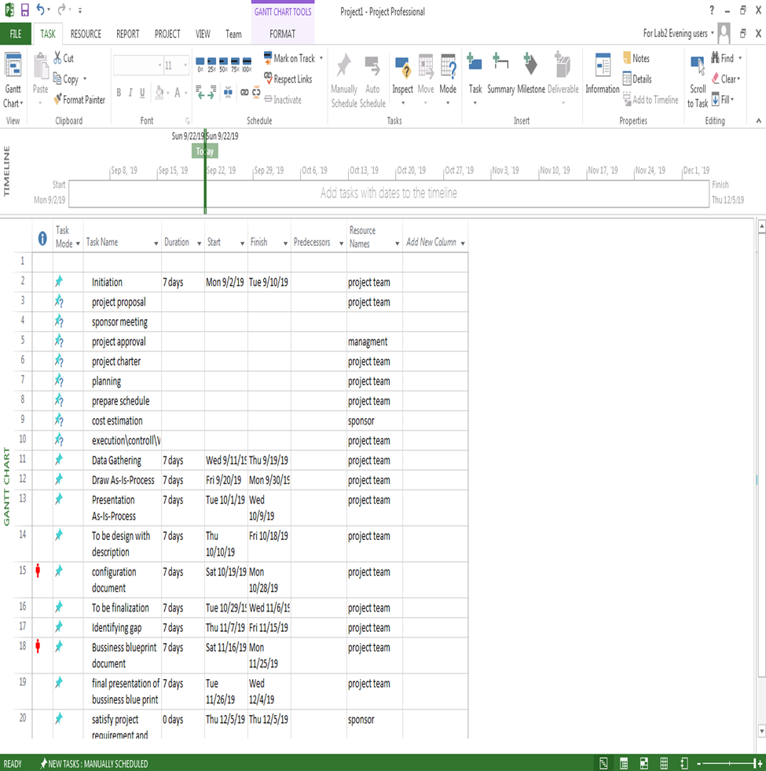

WORK BREAKDOWN

STRUCTURE

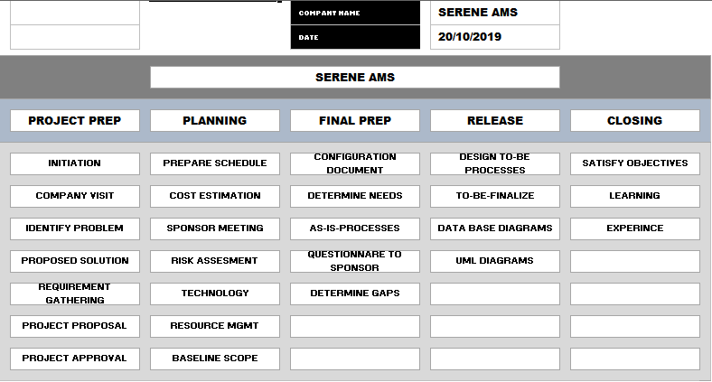

CONFIGURATION

DOCUMENT

**<SERENE AMS >**

**Configuration Management (CM) Plan**

**26/OCT/2019**

**System Description**

This is a management system project and IT based project which will help Airline to manage their departments.

**System Architecture**

This is a web-based application and our client need a server to run this application. As our suggestion is our client need a minimum Core 2 Due System and active internet connection for this Application to perform activities.

**Configuration Management Approach**

**Methods & Tools**

* Asp.net Mvc and Jquery
* C#
* MSSQL
* Java script
* Html
* CSS

**INITIALIZATION ANDBASIC CONFIGURATION**

This section contains basic configuration settings:

**Basic Company Set Up Information**

|  |  |
| --- | --- |
| Company Name:  Used in reports and with the company address information | ***Serene Air Pvt lmtd*** |
| Company Address | Concourse Hall level-2, Opposite Domestic Departure gate, Jinnah International Airport JIAP Karachi |
|  |
| Company Postal Address | **13-K, Moiz Center, F-7 Markaz, Islamabad.** |
|  |
| Company Registration Date | 29 January 2017 |
| Company Incorporation No. |  |
| Internet Address | **customeraffairs@sereneair.com** |
| Phone 1 | 021-34570303 |
|  |
| Phone 2 | +92 51 8491000 |
|  |
| Fax 1 | 92 51 8740000 |
| Fax 2 |  |
| Company general information E-Mail address | **services@sereneair.com** |
|  |
| Local Currency | PKR |
| System Currency | PKR |
| Will your business like to use any of the SAP B1 (SAP Business One) tax features?  Tax types may include  Sales Tax, Income Tax, Special Excise Duty,  Federal Excise Duty. | No |
| Tax Authority Name | Federal Board of Revenue |
| Sindh Revenue Board |

**General Company Settings**

|  |  |
| --- | --- |
| What are the standard posting periods for your business? | Fiscal Calendar : 2019- 2020  Date From: Jan 01 to Dec 31  Number of Periods: 12 Months  Start of Fiscal Year: 01/01/2019 |
| What is the earliest prior period that you would like to enter into SAP Business One to allow for Comparative Financial Statements? | 1st Period (Jan2019) |
| What default payment terms would you like to use for vendor Purchase Order and A/P Invoices  Note: Default payment terms will be attached based on the customer/vendor groups whenever a new record is entered into SAP B-1. | 7-20 days (Purchases)  This setting can be updated at user discretion at document creation level. |
| Which time format would you like to use on the screen display: | 12 Hour |
| Which Date Format would you like to use on the screen display: | DD/MM/YYYY |
| How many decimal places would you like to be displayed and used in calculations for:  *Note: These setting will define the respective number of decimal places that will be displayed for amounts, prices, exchange rates, quantities, percentages, and units. You can increase the selected values at any time. The change will be applied on future actions only, and has no retroactive influence.*  *Your selection effects the calculations in SAP Business One, and the values that will be saved in the data base. For example, if you chose 2 decimal places for amounts and you work with 6 decimal places for very small prices and quantities, totals might be not accurate.* | Decimal Places 0 through 6 available  Currency Amounts 02  Prices 02  Rates 04  Quantities 00  Percentage 02  Units 00 |
| Does your business use Serial Numbered Items  If Yes how do you track them: | Yes, it is stored in system |
| Does your business track items by lots or batches  If Yes how do you track them: | Lot, through system |
| When new items are added to your Item Master file, would you like all items to be available in all warehouses or select which items are available in each warehouse? | Items available in each warehouse |

**Define Currencies**

List the currencies that ***Serene Air*** may use during its sales or purchases process. More currencies may be added later as per the need.

|  |  |  |
| --- | --- | --- |
| **Currency Code** | **Currency Name** | **International Code** |
| PKR | Pakistani Rupees | PKR |
| USD | US Dollar | USD |

**Bank Information**

|  |  |  |  |  |  |  |  |  |
| --- | --- | --- | --- | --- | --- | --- | --- | --- |
| **Bank Code** | **Country** | **Bank Name** | **A/C No** | **IBAN** | **Currency** | **Branch** | **Bank G/L Account** | **Check Clearing G/L Account** |
| Treasury | Pakistan | United Bank Limited |  |  | PKR | Main Branch Karachi |  |  |
| Current | Pakistan | MCB Bank Limited |  |  | PKR | Khayaban-e- Shamsheer |  |  |
| Saving Deposit | Pakistan | Bank AL Habib Limited |  |  | PKR | Main Branch |  |  |

**Warehouses**

|  |  |  |  |
| --- | --- | --- | --- |
| **Warehouse Code (8 Characters)** | **Warehouse Name (100 Characters)** | **Location** | **Drop Ship** |
| 10000000 | Quarantine Warehouse | Logical | No |
| 11000000 | Dispatch Warehouse (QA) | Physical | No |
| 12000000 | Warehouse (all cities) | Physical | No |
| 13000000 | Rejected Item Warehouse | Logical | No |

**Payment Terms**

Terms Code list: Payment terms may be added later as per the business needs.

|  |  |
| --- | --- |
| **Code** | **Description** |
| 0 | Cash Basis |
| 8 | 7 Days Credit |
| 9 | 10 Days Credit |
| 6 | 15 Days Credit |
| 1 | 30 Days Credit |
| 2 | 45 Days Credit |
| 3 | 60 Days Credit |
| 4 | 90 Days Credit |
| 5 | 120 Days Credit |

**Vendor Groups**

Vendor Groups are assigned in the Vendor’s Master File record. These Vendor Groups can be used in Purchase Analysis and other reporting.

|  |  |
| --- | --- |
| **Sr. No** | **Vendor Groups** |
| 01 | Maintenance imported goods. |
| 03 | Maintenance local goods. |
| 04 | Fuel |
| 05 | Others |

|  |  |  |
| --- | --- | --- |
| Tax Authority Name | | Federal Board of Revenue |
| Sindh Revenue Board |
| Punjab Revenue Authority |
|  | |  |
| Does your business track items by lots or batches  If Yes how do you track them: | Lot, through system |
| When new items are added to your Item Master file, would you like all items to be available in all warehouses or select which items are available in each warehouse? | Items available in each warehouse |

**Document Series**

Numbering series defined for master data and documents.

|  |  |  |  |  |  |
| --- | --- | --- | --- | --- | --- |
| **Document** | **Series** | **First No.** | **Last No.** | **Prefix** | **Suffix** |
| **Purchase** | | | | | |
| Purchase Requisition | PR | 10001 | 19999 | PR |  |
|  |  |  |  |  |  |
| Purchase Order | PO | 20001 | 29999 | PO |  |
|  | | | | | |
| A/P Down Payment | APD | 30001 | 39999 | APD |  |
|  | | | | |  |
| Goods Receipt PO (GRN) | GR | 40001 | 49999 | GR |  |
|  | | | | | |
| A/P Invoice | AP | 50001 | 59999 | AP |  |
|  | | | | | |
| Goods Return | GR | 60001 | 69999 | GR |  |
|  | | | | | |
| A/P Credit Memo | APC | 70001 | 79999 | APC |  |
|  | | | | | |
|  | | | | | |
| Goods Receipt | GR | 40001 | 49999 | GR |  |
|  | | | | | |
| Goods Issue | GI | 80001 | 89999 | GI |  |
|  | | | | | |
|  | | | | | |

**HCM ORG STRUCTURE:**

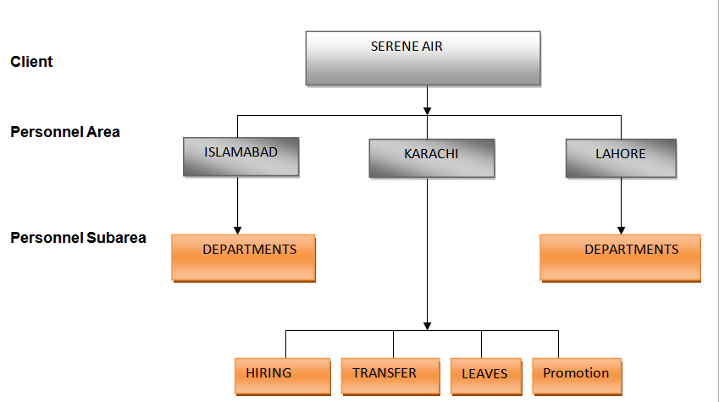

**DEPARTMENTS**

**WORK SCHEDULE:**

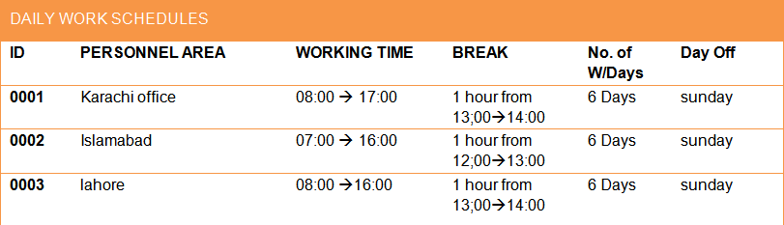

**ABSENCE TYPES:**

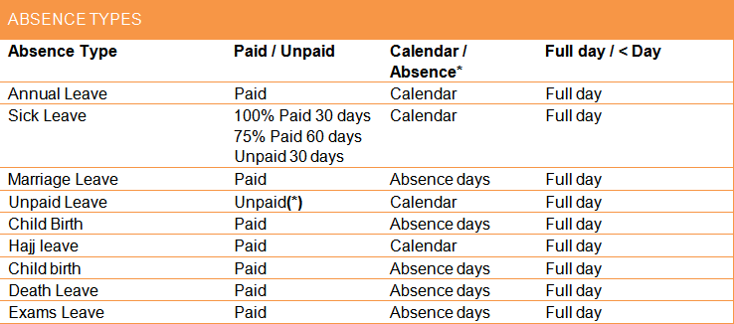

**ABSENCE QUOTA TYPES:**

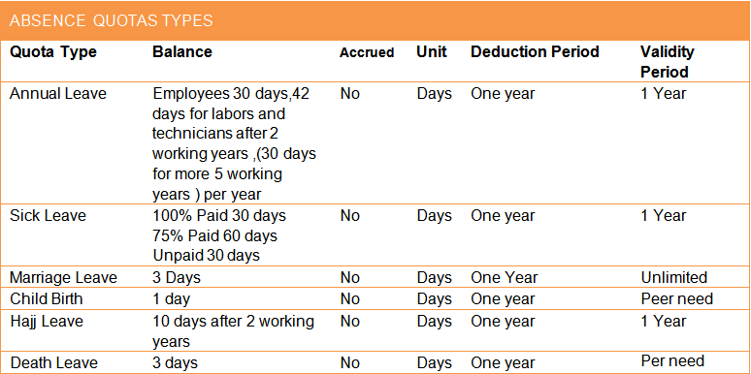

**HOLIDAYS CALENDER:**

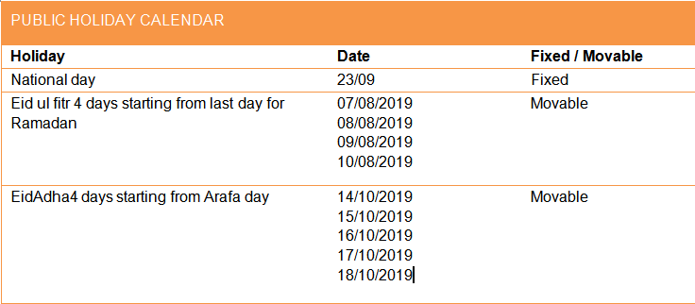

**FINANCIAL IMPACT**

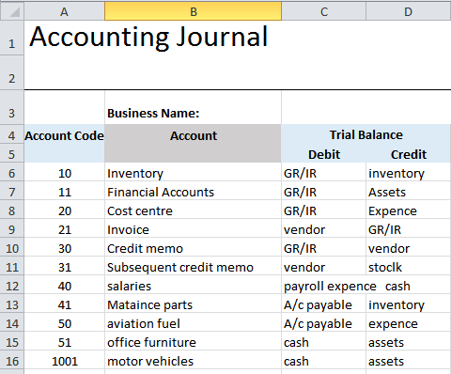

AS-IS-PROCESSES

**As-Is-Process Recuritment:**

* Candidate send application form
* Recruitment officer scrutinizes application and enter data on excel sheet
* NTS consultant conduct test
* Successful candidate’s receive interview call by competent authority
* Successful candidate in interview are send job letters.

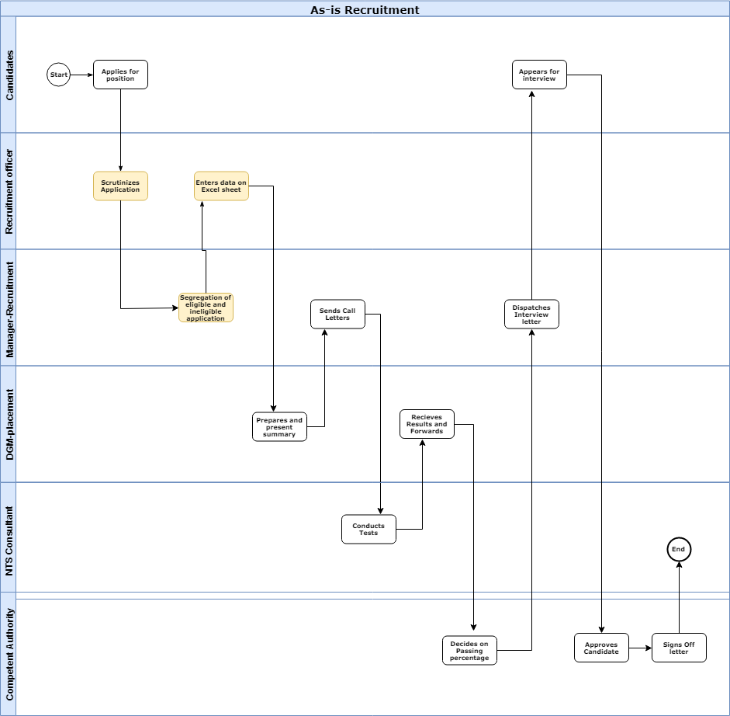

**AS-IS-EMPLOYEE PROMOTION:**

* HR manager prepare and send list
* DGM HR scrutinize cases
* HR manager prepare letters and send to employees

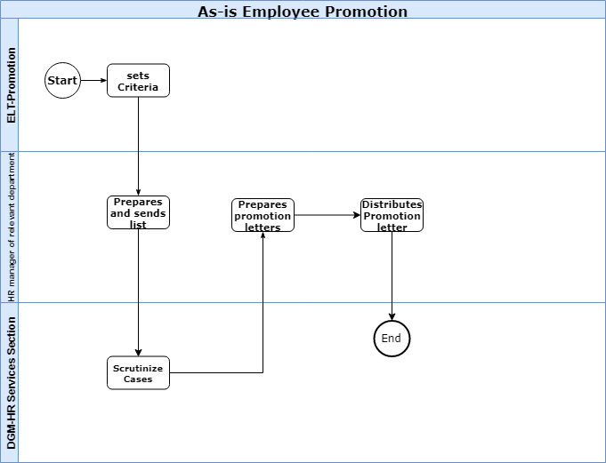

**AS-IS-EMPLOYEE LEAVE:**

* Employee submits application for leave to HR manager.
* HR manager of relevant depart prepare and submit a minute
* Manager approves leave and conveyed to employee

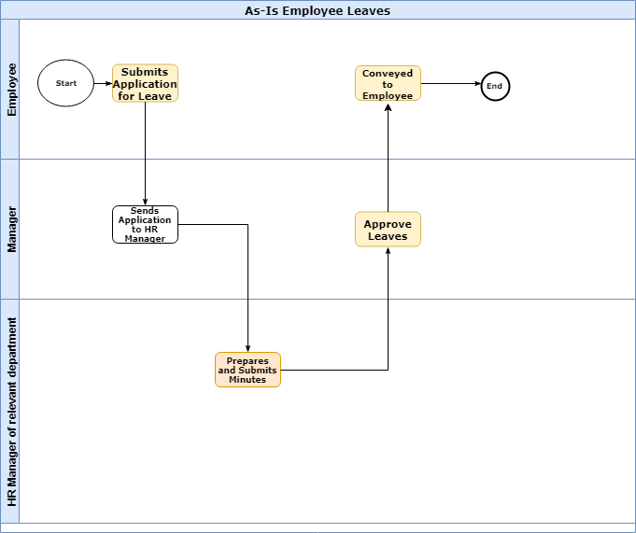

**AS-IS-PROCESS-EMPLOYEE TRANSFER ON REQUEST:**

* Employee request for transfer.
* HR manager writes vacancy.
* GM of concerned department sign approval
* HR manager prepare transfer order and convey it to employee

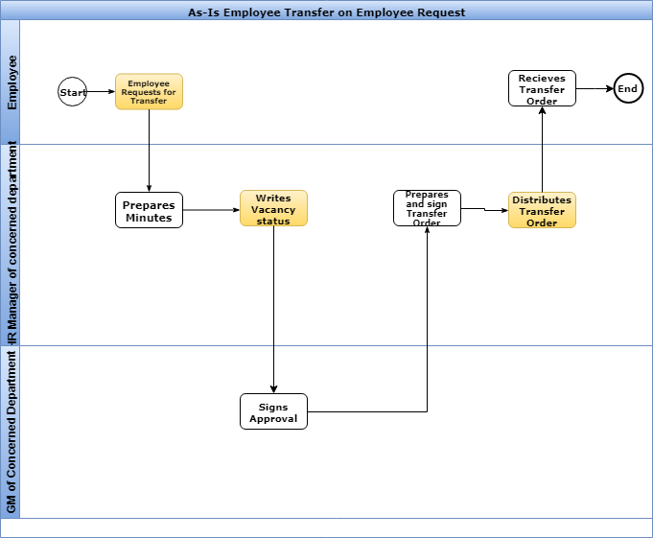

**Material Managment(material) Department Process**

* Company approves for requirement and pays due to courier.
* After receiving item custom clearance
* Quantity control write release note after receiving item
* Quality inspection is carried out of items
* Items placed in store

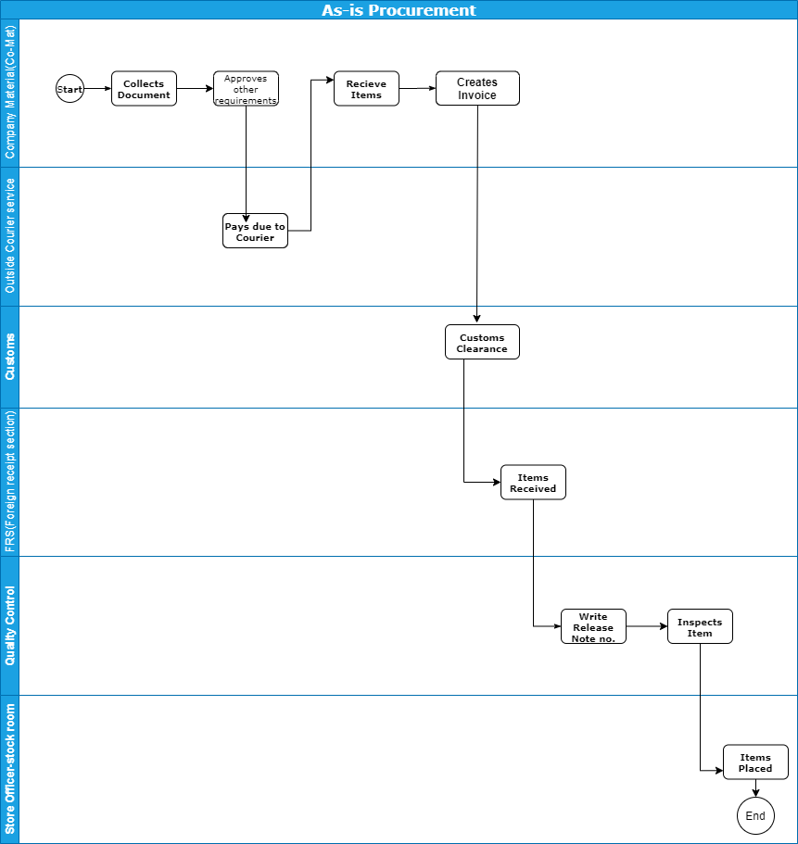

* Store officer inspects items prepare report
* Quality officer inspect items
* Surveyor prepares survey report of defected items and sends to insurer for goods claims.

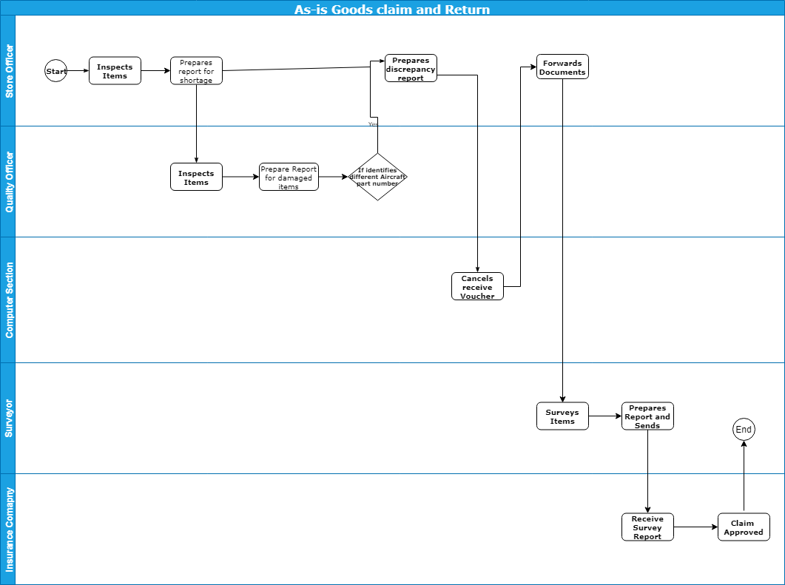

**QUESTIONNARE**

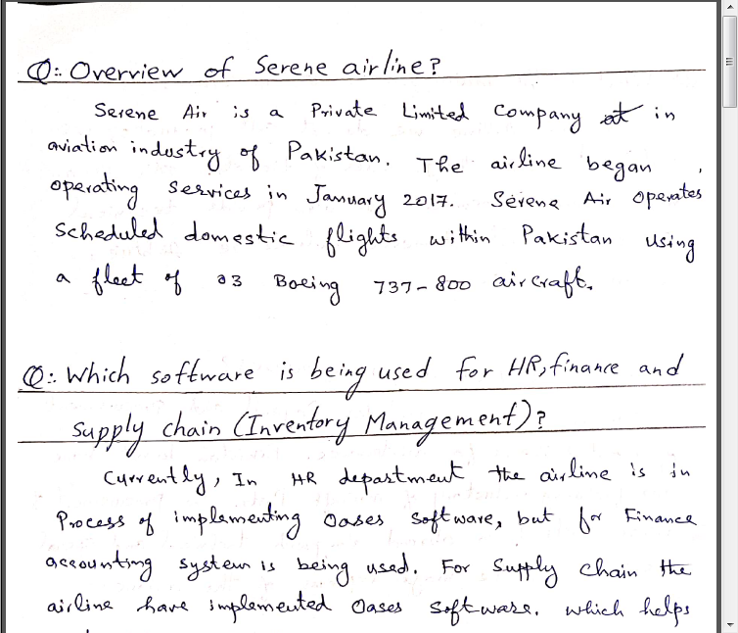

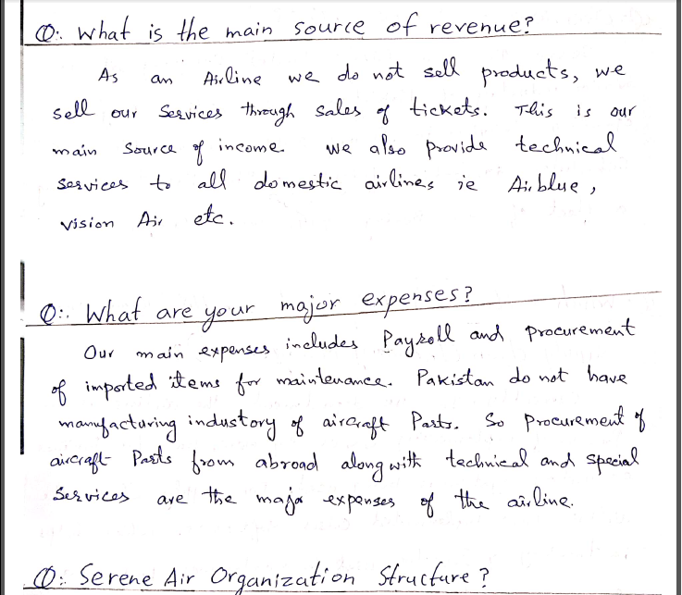

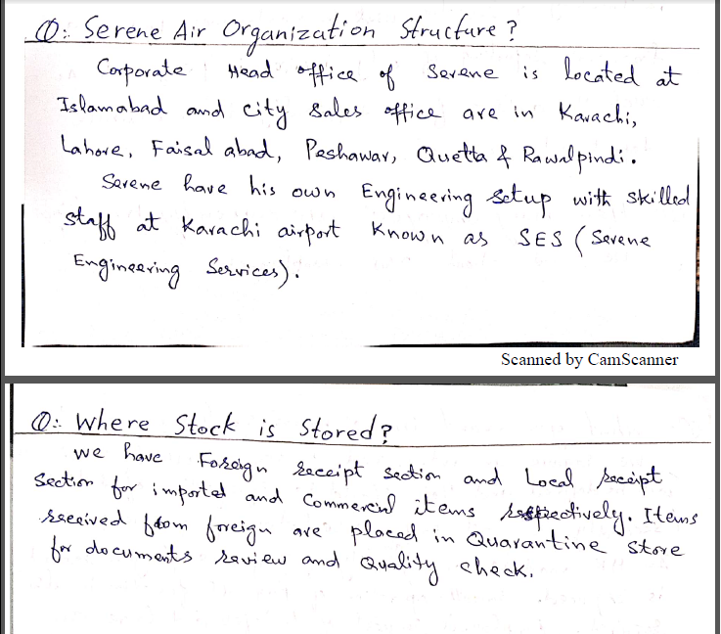

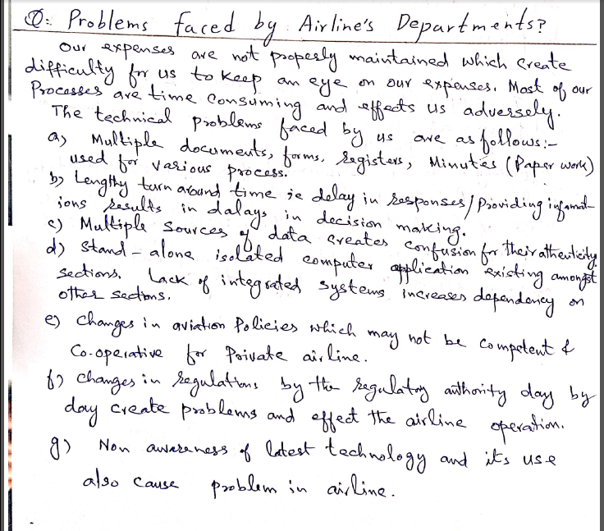

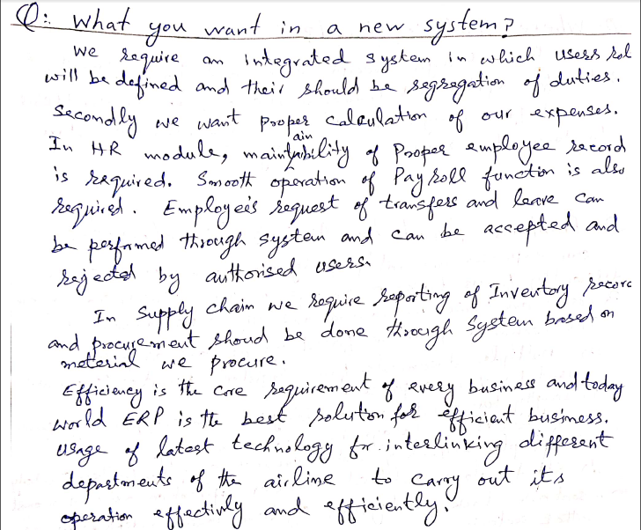

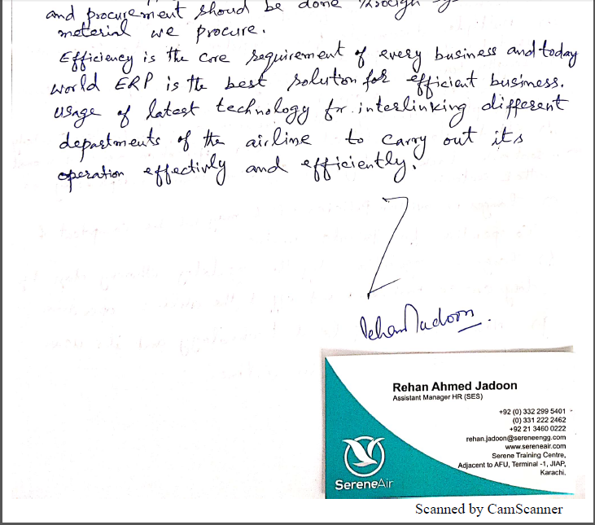

**GAP ANALYSIS**

|  |  |  |  |
| --- | --- | --- | --- |
| Process: | **AS-is** | **To-Be** |  |
| HR Recruitment | In As-is process, the entire process was time consuming. The candidate had to first fill form on a paper. Multiple employees also had to do work. | In To-be process, the process is time saving. The candidate can fill form online. Single Manager handles various processes. |  |
| HR Promotion | In As-is process, the employee was told about promotion through Promotion letter. Which was needed to be typed and was sent to employee. | In To-be process, the employee will get notification even before promotion letter is received and Promotion letter will be generated by system and sent to employee. |  |
| HR Leave | In As-is process, HR manager had to Prepare minutes. | HR manager will get leave information of employee who applied for leave and approval will be given based on reason. |  |
| HR Transfer | HR manager had to prepare and write vacancy status. | System will show vacancy status. |  |
| Supply chain | In As-is process, Store manager had to physically calculate stock and report shortage and quality manager checks damage of items. | System will show shortage of item based on re-order point. |  |
|  |  |  |  |

TO-BE-PROCESSES

**TO-BE-RECRUITMENT:**

* Recruitment officer creates vacancy
* Candidate fills online application form
* Recruitment officer segregates application forms
* Recruitment manager receives approved application list
* Candidates give test
* Recruitment officer receives marks list and approve candidates on passing percentage.
* Recruitment officer dispatch call letters
* Candidate receive call letters and give interview
* DGM placement approve candidate on basis of interview
* Successful candidate receive offer letter.

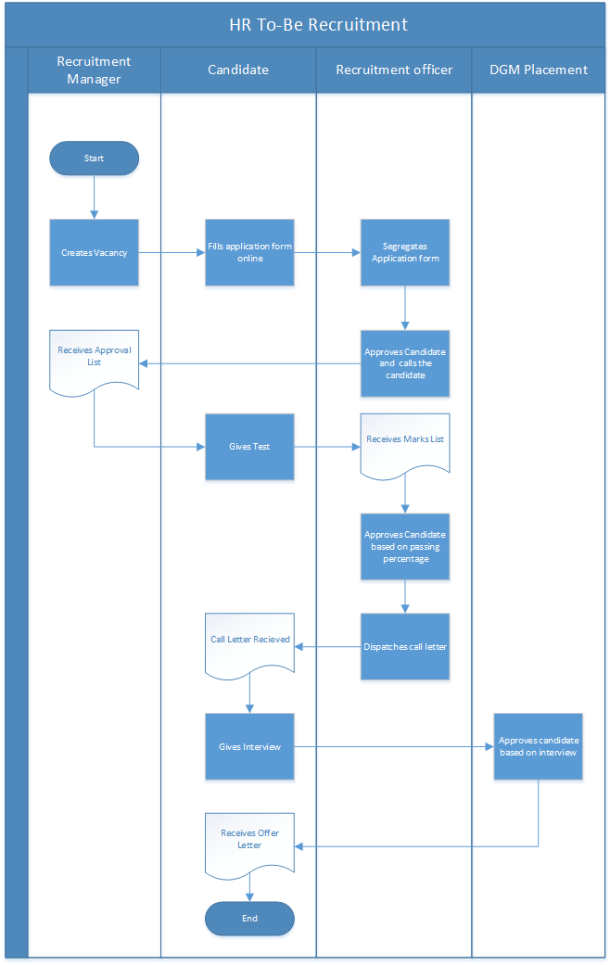

**TO-BE-PROMOTION:**

* HR manager approve promotion on board decision.
* Finance manager update employee pay scale
* Employee receive Notification

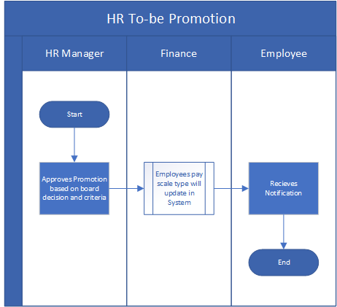

**HR TO-BE-LEAVE:**

* Employee request leave and if employee left with leaves HR manger approves or dis approves on basis of reason.
* Employee gets notification.

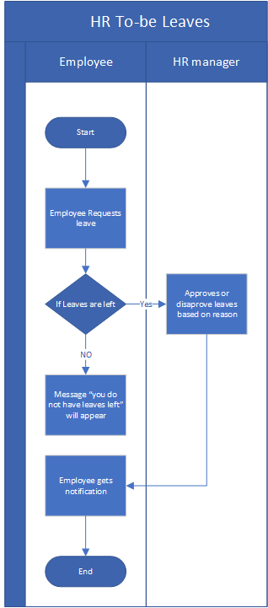

**TO-BE-TANSFER ON REQUEST:**

* Employee request for transfer.
* If vacancy available GM approves or dis approve on basis of transfer reason
* Employee gets notification.

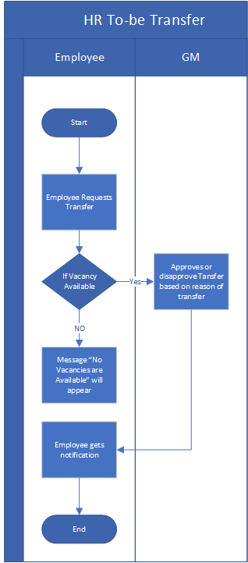

**MM-TO-BE-PROCREMENT:**

* Inventory manager creates PR and PO and send to vendor.
* Store manager make GR on delivered items and GR for maintained items. Finance department makes payment.
* Store manager sends GRN to Quality manager for Goods return process.
* Store manager makes Good issue for approved items
* Store manager checks if shortage items if yes then request Inventory manager to create PR

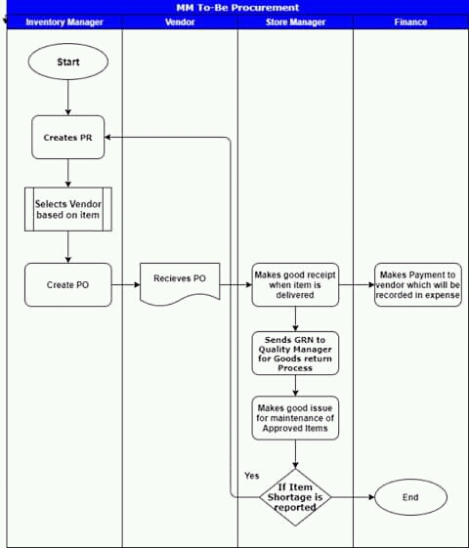

**MM-TO-BE-GOODS RETURN:**

* Store manager create GRN note and Quality manager check items procured.
* If items are damaged they are send back to vendor by store manager and if not store manager approve items.
* Vendor create Return note of damage items and send to Quality manager.
* Relevant credit/debit memo created by finance department on Return note.

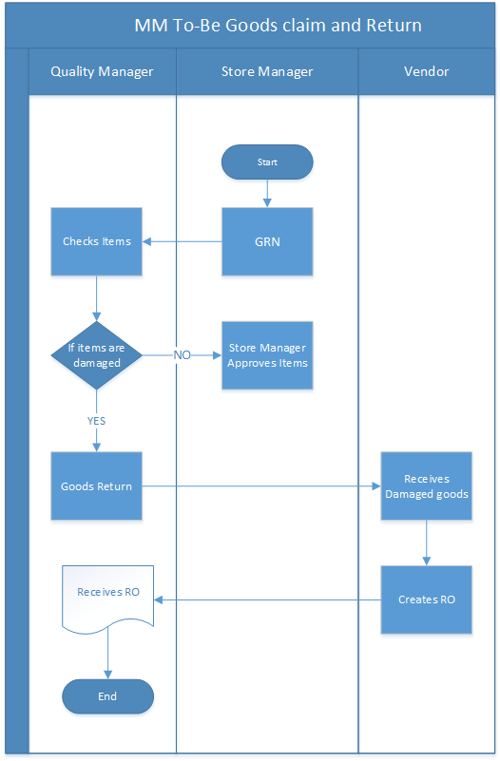

**UML DIAGRAMS**

**CLASS DIAGRAM:**

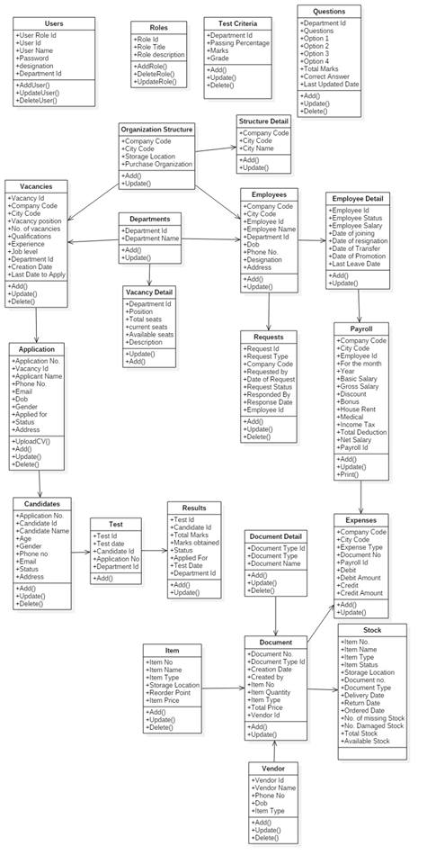

**USE CASE DIAGRAM:**

**ADMIN USE CASE:**

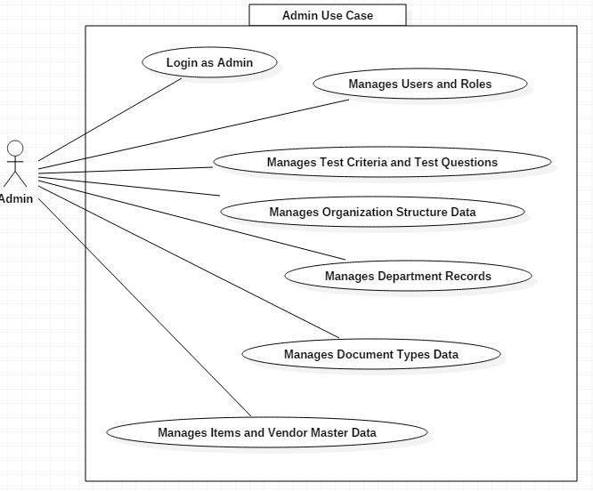

**RECRUITMENT USECASE:**

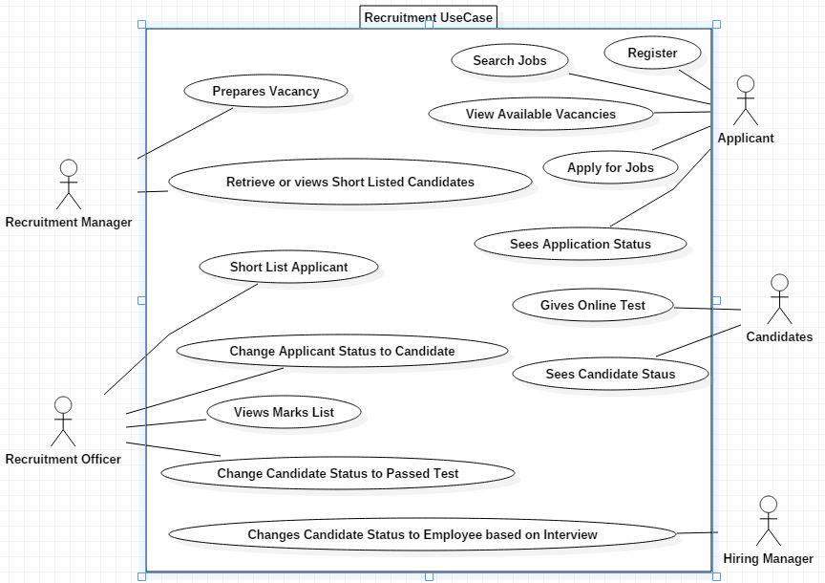

**TRANSFER ON EMPLOYEE REQUEST:**

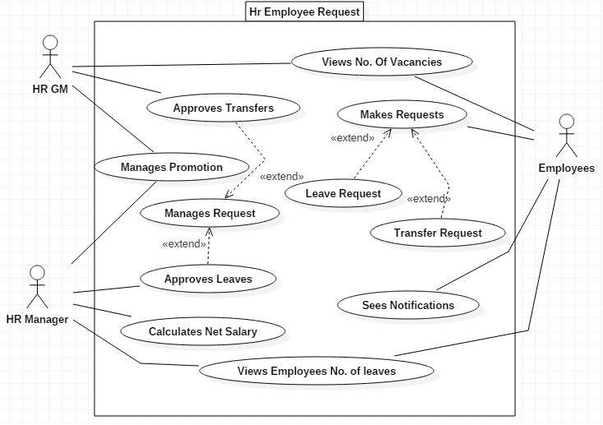

**MM USE CASE:**

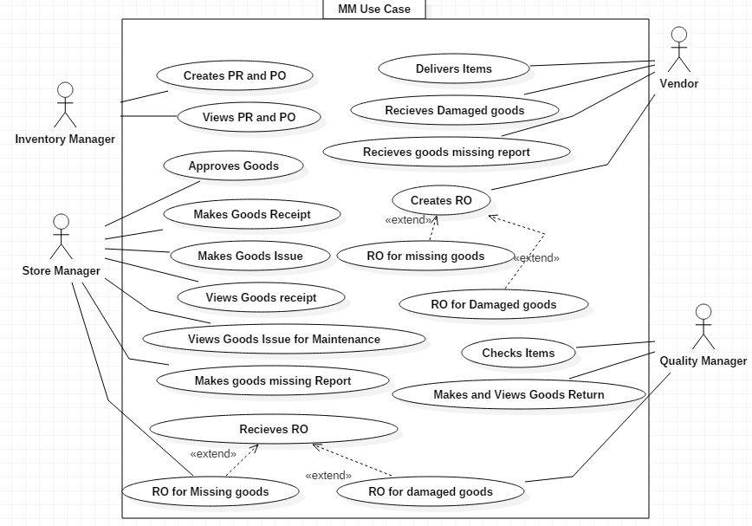

**SEQUENCE DIAGRAMS:**

**RECRUITMENT:**

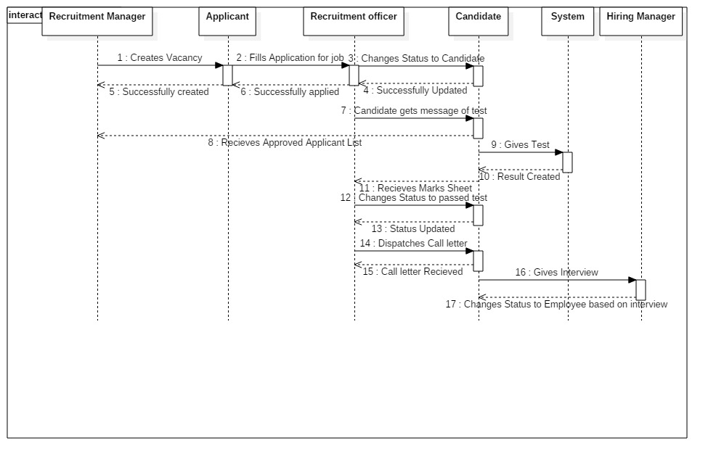

**EMPLOYEE LEAVE:**

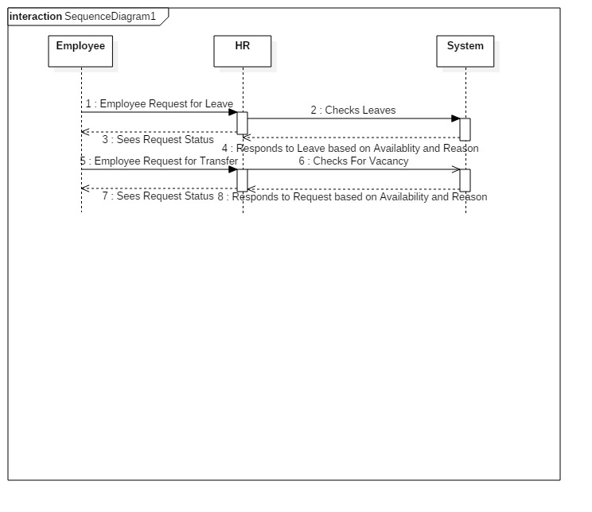

**EMPLOYEE PROMOTION:**

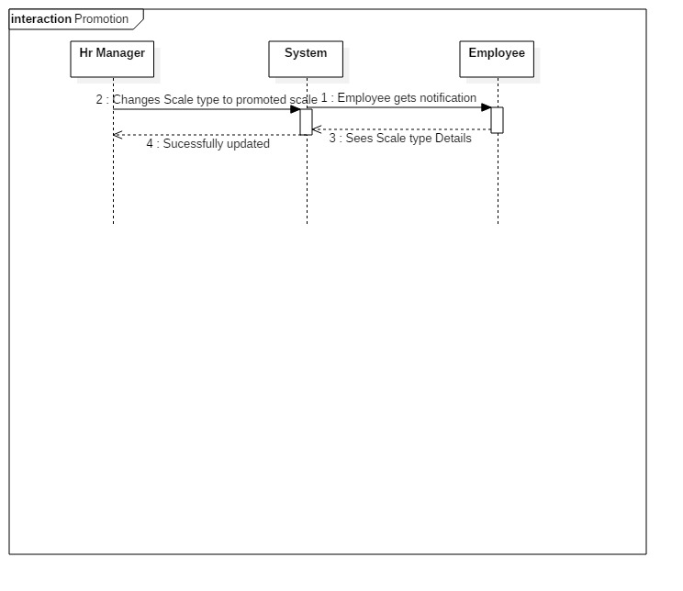

**PROCUREMENT:**

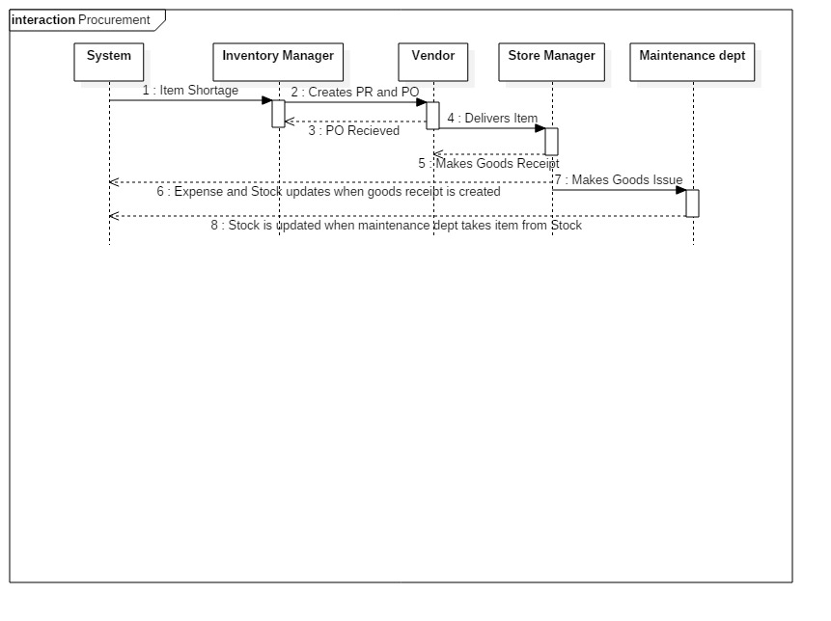

**Goods Return:**

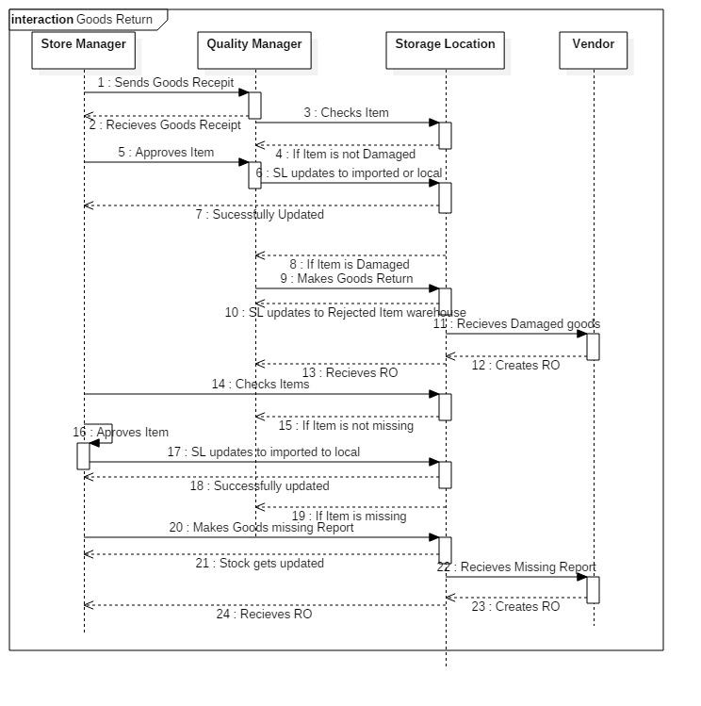

**SIGNATURE :**

